The Nature of Physical Chemistry and Kinetic Theory of Gases
1. State whether the following properties are intensive or extensive: (a) mass; (b) density; (c) temperature; (d) gravitational field.
2. An ideal gas occupies a volume of 0.300 dm³ at a pressure of 1.80 × 10⁵ Pa. What is the new volume of the gas maintained at the same temperature if the pressure is reduced to 1.15 × 10⁵ Pa?

3. If the gas in Problem 2 were initially at 330 K, what will be the final volume if the temperature were raised to 550 K at constant pressure?

4. Calculate the concentration in mol dm^{–3} of an ideal gas at 298.15 K and at (a) 101.325 kPa (1 atm), and (b) 1.00 × 10^{–4} Pa (= 10^{–9} atm). In each case, determine the number of molecules in 1.00 dm³.

5. A Dumas experiment to determine molar mass is conducted in which a gas sample’s P, θ, and V are determined. If a 1.08-g sample is held in 0.250 dm³ at 303 K and 101.3 kPa:
a. What would the sample’s volume be at 273.15 K, at constant pressure?
b. What is the molar mass of the sample?

6. A gas that behaves ideally has a density of 1.92 g dm^{–3} at 150 kPa and 298 K. What is the molar mass of the sample?

7. The density of air at 101.325 kPa and 298.15 K is 1.159 g dm^{–3}. Assuming that air behaves as an ideal gas, calculate its molar mass

8. The decomposition of KClO₃ produces 27.8 cm³ of O₂ collected over water at 27.5 °C. The vapor pressure of water at this temperature is 27.5 Torr. If the barometer reads 751.4 Torr, find the volume the dry gas would occupy at 25.0 °C and 1.00 bar.

The First Law of Thermodynamics

1.A bird weighing 1.5 kg leaves the ground and flies to a height of 75 metres, where it attains a velocity of 20 m s^{–1}. What change in energy is involved in the process? (Acceleration of gravity = 9.81 m s^{–2}.)

2. An average man weighs about 70 kg and produces about 10 460 kJ of heat per day.
a. Suppose that a man were an isolated system and that his heat capacity were 4.18 J K^{–1} g^{–1}; if his temperature were 37 °C at a given time, what would be his temperature 24 h later?
b. A man is in fact an open system, and the main mechanism for maintaining his temperature constant is evaporation of water. If the enthalpy of vaporization of water at 37 °C is 43.4 kJ mol^{–1}, how much water needs to be evaporated per day to keep the temperature constant?

3. In an open beaker at 25 °C and 1 atm pressure, 100 g of zinc are caused to react with dilute sulfuric acid. Calculate the work done by the liberated hydrogen gas, assuming it behaves ideally. What would be the work done if the reaction took place in a sealed vessel?

4. Using the data given in Table 2.1 and Appendix D, find the enthalpy change for the reaction 2H₂(g) + O₂(g) → 2H₂O(g) at 800 K.

5. A sample of liquid benzene weighing 0.633 g is burned in a bomb calorimeter at 25.00 °C, and 26.54 kJ of heat are evolved.
a. Calculate ΔU_{m}
b. Calculate ΔH_{m}

6. Deduce the standard enthalpy change for the process:
2CH₄(g) → C₂H₆(g) + H₂(g) (data in Appendix D)
6. A sample of liquid methanol weighing 5.27 g was burned in a bomb calorimeter at 25.00 °C, and 119.50 kJ of heat was evolved (after correction for standard conditions).
a. Calculate Δ_{c} H° for the combustion of 1 mol of methanol.
b. Use this value and the data in Appendix D for H₂O(l) and CO₂(g) to obtain a value for Δ_{f} H°(CH₃OH,l), and compare with the value given in the table.
c. If the enthalpy of vaporization of methanol is 35.27 kJ mol^{–1}, calculate Δ_{f} H° for CH₃OH(g).

7. Calculate the heat of combustion () of ethane from the data given in Appendix D. HcΔ°

8.Suggest a practicable method for determining the enthalpy of formation Δ_{f} H° of gaseous carbon monoxide at 25 °C. (Note: Burning graphite in a limited supply of oxygen is not satisfactory, since the product will be a mixture of unburned graphite, CO, and CO₂.)
9.If the enthalpy of combustion Δ_{c}H° of gaseous cyclopropane, C₃H₆, is –2091.2 kJ mol^{–1} at 25 °C, calculate the standard enthalpy of formation Δ_{f} H°.

10. From the data in Appendix D, calculate ΔH° for the reaction (at 25 °C):
C₂H₄(g) + H₂O(l) → C₂H₅OH(l)

11. 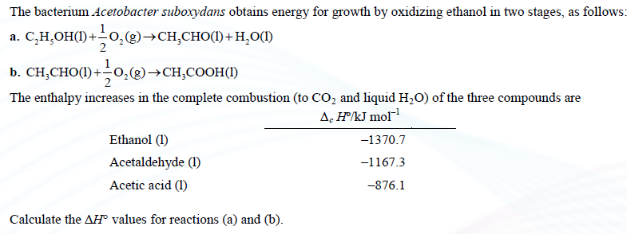

12. Calculate ΔH for the reaction;
C₂H₅OH(l) + O₂(g) → CH₃COOH(l) + H₂O(l)
making use of the enthalpies of formation given in Appendix D. Is the result consistent with the results obtained for Problem 11?

13. 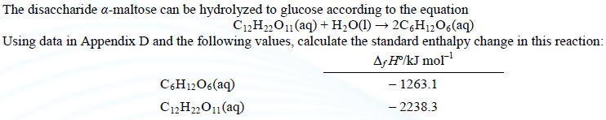
14. The standard enthalpy of formation of the fumarate ion is –777.4 kJ mol^{–1}. If the standard enthalpy change of the reaction:
fumarate^{2–}(aq) + H₂(g) → succinate^{2–} (aq)
is 131.4 kJ mol^{–1}, calculate the enthalpy of formation of the succinate ion.

15. The ΔH° for the mutarotation of glucose in aqueous solution,
α-D-glucose(aq) → β-D-glucose(aq)
has been measured in a microcalorimeter and found to be –1.16 kJ mol^{–1}. The enthalpies of solution of the two forms of glucose have been determined to be
α-D-glucose(s) → α-D-glucose(aq)
ΔHº = 10.72 kJ mol^{–1}
β-D-glucose(s) → β-D-glucose(aq)
ΔHº = 4.68 kJ mol^{–1}
Calculate ΔH° for the mutarotation of solid α-D-glucose to solid β-D-glucose.

16. Use the data in Appendix D to calculate ΔH° for the hydrolysis of urea into carbon dioxide and ammonia at 25 °C.

17. From the data in Table 2.1 and Appendix D, calculate the enthalpy change in the reaction
C(graphite) + O₂(g) → CO₂(g)
at 1000 K.

18. A sample of sucrose, C₁₂H₂₂O₁₁ weighing 0.1328 g, was burned to completion in a bomb calorimeter at 25 °C, and the heat evolved was measured to be 2186.0 J.
a. Calculate Δ_{c}U_{m} and Δ_{c}H_{m} for the combustion of sucrose.
b. Use data in Appendix D to calculate Δ_{f} H_{m} for the formation of sucrose.

19. 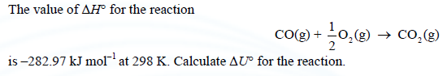

20. A chemical reaction occurs at 300 K in a gas mixture that behaves ideally, and the total amount of gas increases by 0.27 mol. If ΔU = 9.4 kJ, what is ΔH?

The Second and Third Laws of Thermodynamics

1.
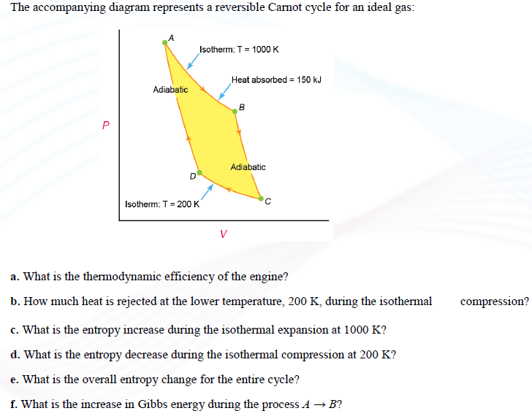

2. An engine operates between 125 °C and 40 °C. What is the minimum amount of heat that must be withdrawn from the reservoir to obtain 1500 J of work?

3.a. Figure 3.2 shows a Carnot cycle in the form of a pressure-volume diagram. Sketch the corresponding entropy-temperature diagram, labeling the individual steps A → B (isotherm at T_{h}), B → C (adiabatic), C → D (isotherm at T_{c}), and D → A (adiabatic).
b. Suppose that a reversible Carnot engine operates between 300 K and a higher temperature T_{h}. If the engine produces 10 kJ of work per cycle and the entropy change in the isothermal expansion at T_{h} is 100 J K^{–1}, what are q_{h}, q_{c}, and T_{h}?
4. 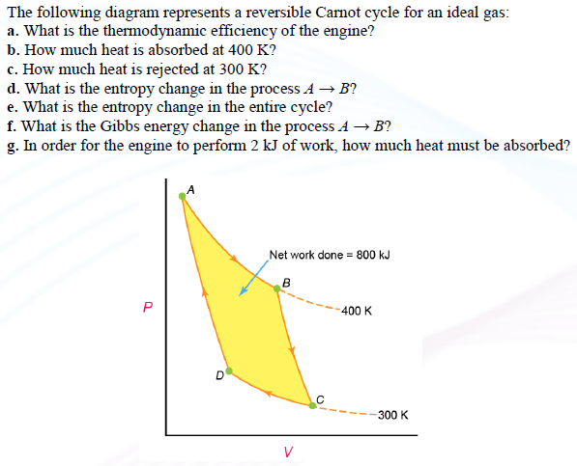

5. Suppose that an iceberg weighing 10⁹ kg were to drift into a part of the ocean where the temperature is 20 °C. What is the maximum amount of work that could be generated while the iceberg is melting? Assume the temperature of the iceberg to be 0 °C. The latent heat of fusion of ice is 6.025 kJ mol^{–1}.]]
If the process occurred in one day, what would be the power produced?
6. 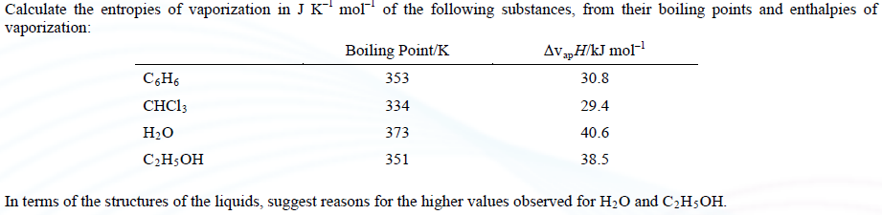

7. Calculate the standard entropies of formation of (a) liquid methanol and (b) solid urea, making use of the absolute entropies listed in Table 3.2 (p. 120).

8. Calculate the standard entropies for the following reactions at 25 °C:
a. N₂(g) + 3H₂(g) → 2NH₃(g)
b. N₂O₄(g) → 2NO₂(g)

9.

10.

11.

12. Calculate the entropy of mixing per mole of air, taking the composition by volume to be 79% N₂, 20% O₂, and 1% Ar.

13.
From the data given in Table 3.2 (p. 120), calculate the standard entropy of formation Δ_{f} S° of liquid ethanol at 25 °C.

14.

15.
The absolute entropy of nitrogen at its vaporization point of 77.32 K and exactly 1 bar is 151.94 J K^{–1} mol^{–1}. Using the expression for C_{P,m} for nitrogen given in Table 2.1, find the entropy of the gas at 800.0 K and 1 bar.

16. 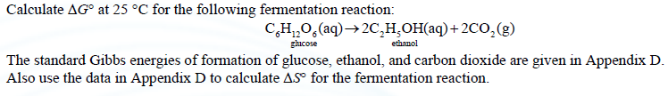

17.
The latent heat of vaporization of water at 100 °C is 40.6 kJ mol^{–1} and when 1 mol of water is vaporized at 100 °C and 1 atm pressure, the volume increase is 30.19 dm³. Calculate the work done by the system, the change in internal energy ΔU, the change in Gibbs energy ΔG and the entropy change ΔS.

18.
The values of ΔH and ΔS for a chemical reaction are –85.2 kJ mol^{–1} and –170.2 J K^{–1} mol^{–1}, respectively, and the values can be taken to be independent of temperature.
a. Calculate ΔG for the reaction at (a) 300 K, (b) 600 K, and (c) 1000 K.
b. At what temperature would ΔG be zero?

19.
Initially at 300 K and 1 bar pressure, 1 mol of an ideal gas undergoes an irreversible isothermal expansion in which its volume is doubled, and the work it performs is 500 J mol^{–1}. What are the values of q, ΔU, ΔH, ΔG, and ΔS? What would q and w be if the expansion occurred reversibly?

20.
Calculate ΔH°, ΔG°, and ΔS° for the reaction
CH₄(g) + 2O₂(g) → O₂(g) + 2H₂O(l)
making use of the data in Appendix D.

21. 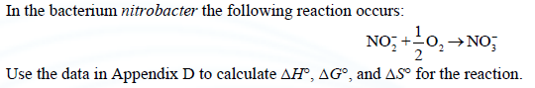

22.
A cooling system is designed to maintain a refrigerator at –4 °C in a room at 20 °C. If 10⁴ J of heat leaks into the refrigerator each minute, and the system works at 40% of its maximum thermodynamic efficiency, what is the power requirement in watts? [1 watt (W) = 1 J s^{–1}.]

23.
A typical automobile engine works with a cylinder temperature of 2000 °C and an exit temperature of 800 °C. A typical octane fuel (molar mass = 114.2 g mol^{–1}) has an enthalpy of combustion of –5500 kJ mol^{–1} and 1 dm³ (0.264 U.S. gal) has a mass of 0.80 kg. Calculate the maximum amount of work that could be performed by the combustion of 10 dm³ of the fuel.

Chemical Equilibrium

1.A reaction occurs according to the equation
2A →Y + 2Z
If in a volume of 5 dm³ we start with 4 mol of pure A and find that 1 mol of A remains at equilibrium, what is the equilibrium constant K_{c}?

2. 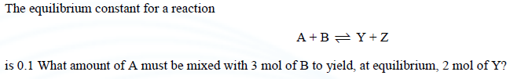

3. 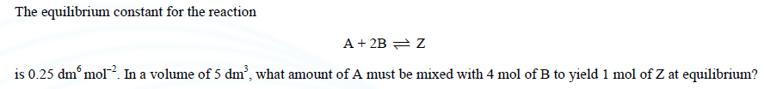

4. 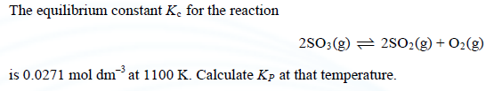

5. 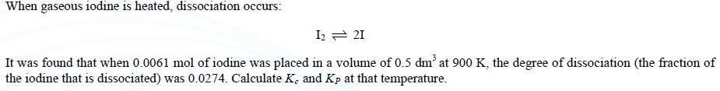

6. 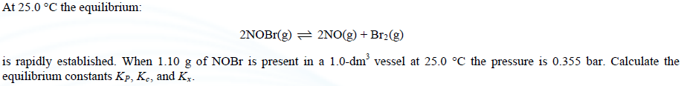

7.

8. 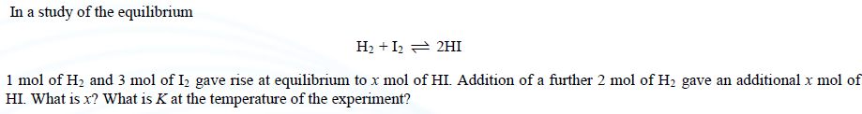

9.
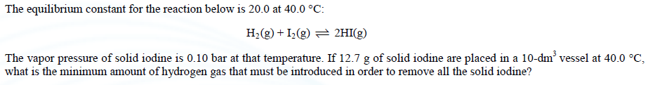

10.
The degree of dissociation α of N₂O₄(g) is 0.483 at 0.597 bar and 0.174 at 6.18 bar. The temperature is 298 K for both measurements. Calculate K_{P}, K_{c}, and K_{x} in each case.

11.
12.
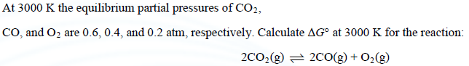
13.
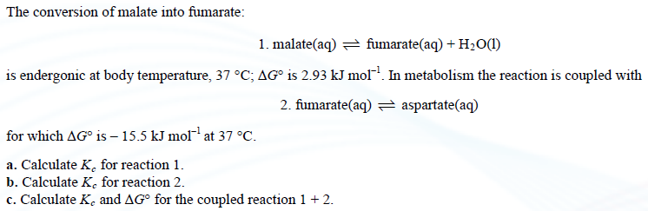
14. 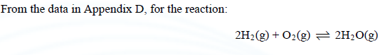
Calculate the following:
a. ΔG°, ΔH°, and ΔS° at 25 °C (standard state: 1 bar).
b. K_{P} at 25 °C.
c. ΔG° and K_{P} at 2000 °C, on the assumption that ΔH° and ΔS° are temperature independent.

15.
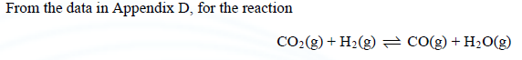
Calculate the following:
a. ΔH°, ΔG°, and ΔS° (standard state: 1 bar and 25 °C).
b. The equilibrium constant at 25 °C.
c. From the heat capacity data in Table 2.1, obtain an expression for ΔH° as a function of temperature.
d. Obtain an expression for ln K_{P} as a function of temperature.
e. Calculate K_{P} at 1000 K.

16.

17.

18.
At 1 bar pressure liquid bromine boils at 58.2 °C, and at 9.3 °C its vapor pressure is 0.1334 bar. Assuming ΔH° and ΔS° to be temperature independent, calculate their values, and calculate the vapor pressure and ΔG° at 25 °C.

19.
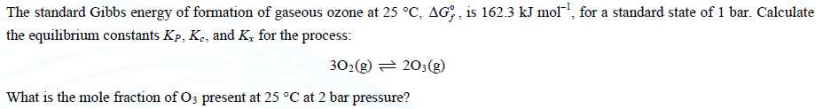

Phase Equilibria
1.Determine the number of degrees of freedom for the following systems:
a. A solution of potassium chloride in water at the equilibrium pressure. b. A solution of potassium chloride and sodium chloride at 298 K at 1 atm pressure. c. Ice in a solution of water and alcohol.
2.
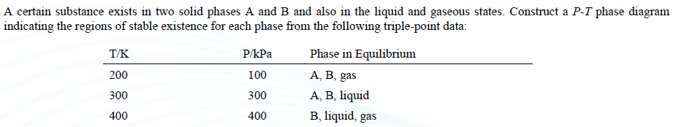

3.
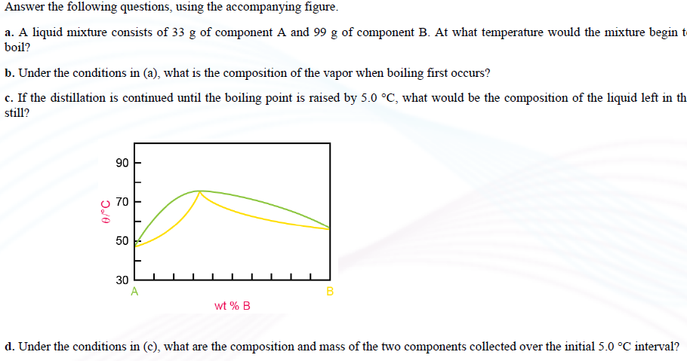

4.
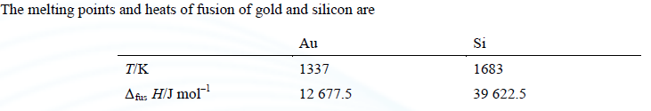

For the data, calculate the solid-liquid equilibrium lines and estimate the eutectic composition graphically.

5.

Use the following data to construct a phase diagram of the phenol–water system and answer the following questions (the compositions are given in grams of phenol in 100 grams of solution):
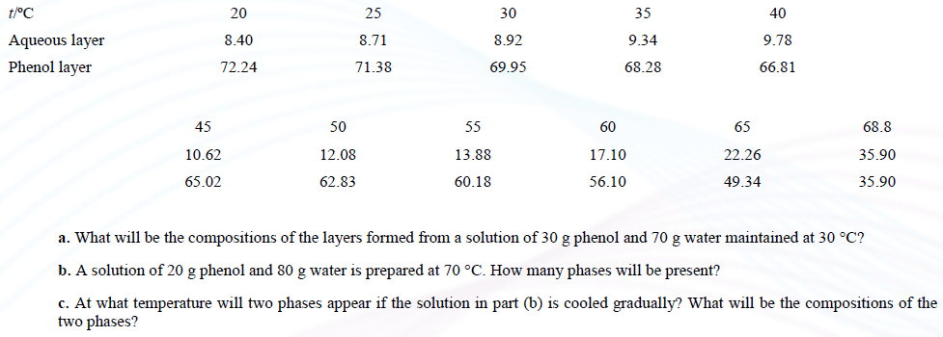

6.

A fictitious ternary system composed of liquids A, B, and C was constructed by adding the component B to various binary A–C mixtures and noting the point at which complete miscibility occurred. The following are the mole-percents of A and B at which complete miscibility was observed. Construct the phase diagram on a triangular graph paper.

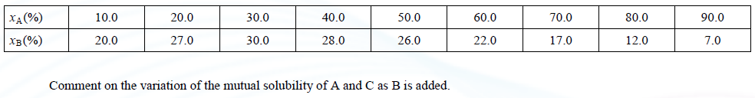
7.